Change all button color like first row.

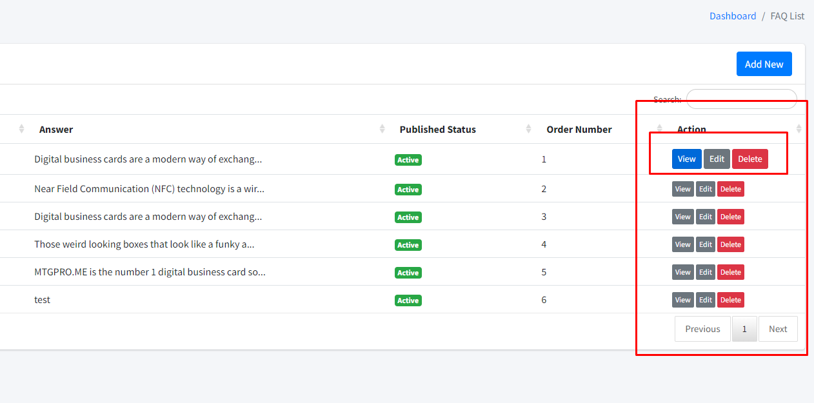

1. Add blog category page. Input field should be number.

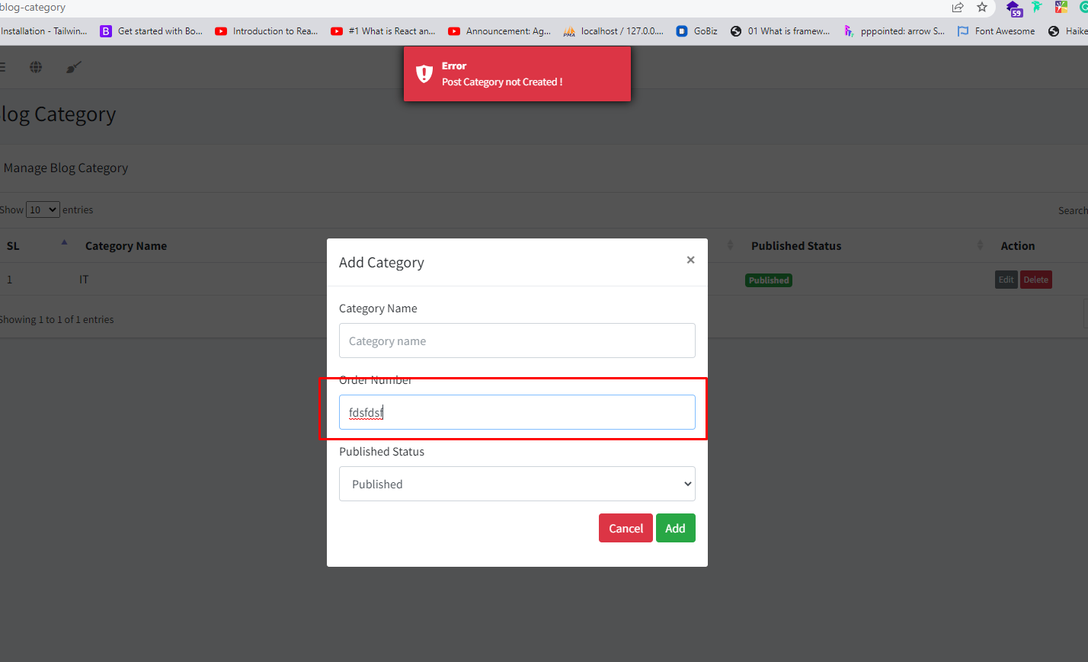

Change message (Category Added Successfully).

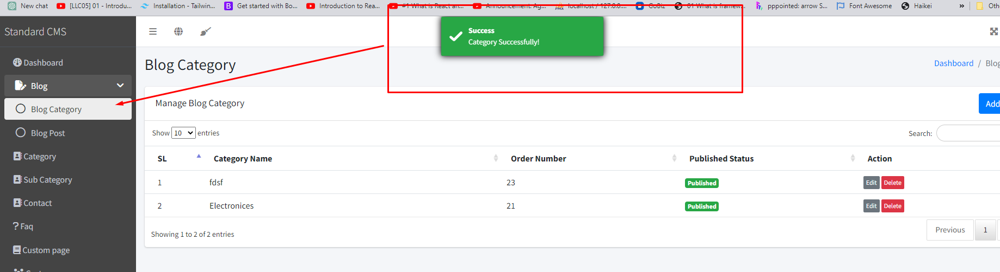

2. Blog Category update not working.

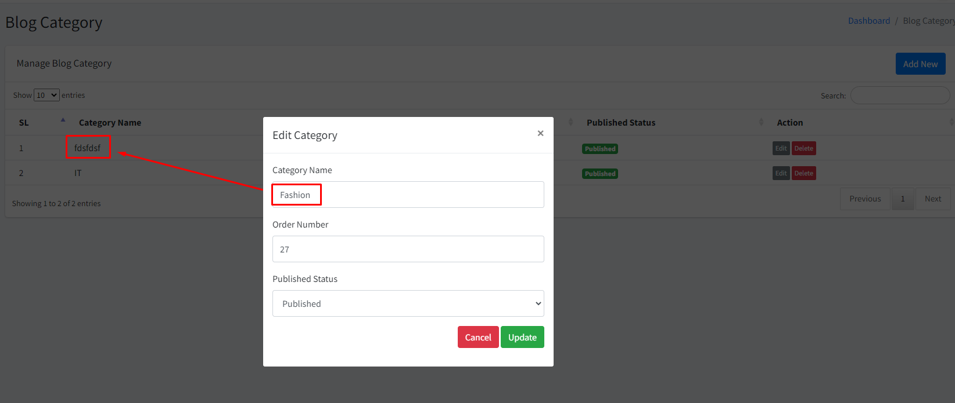

3. Blog post

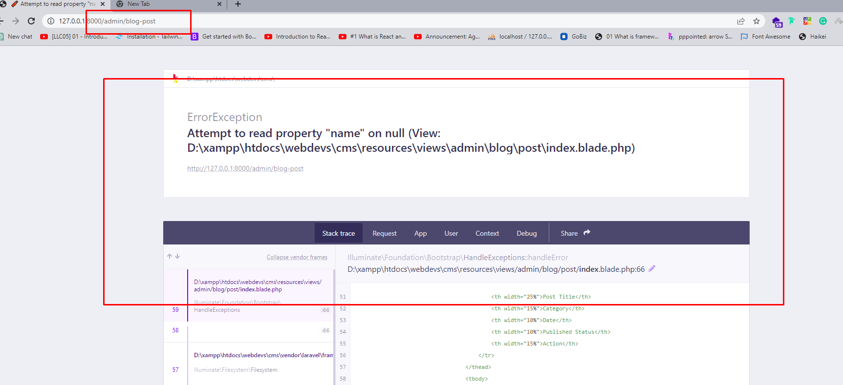

4. Add category order number field should be number.

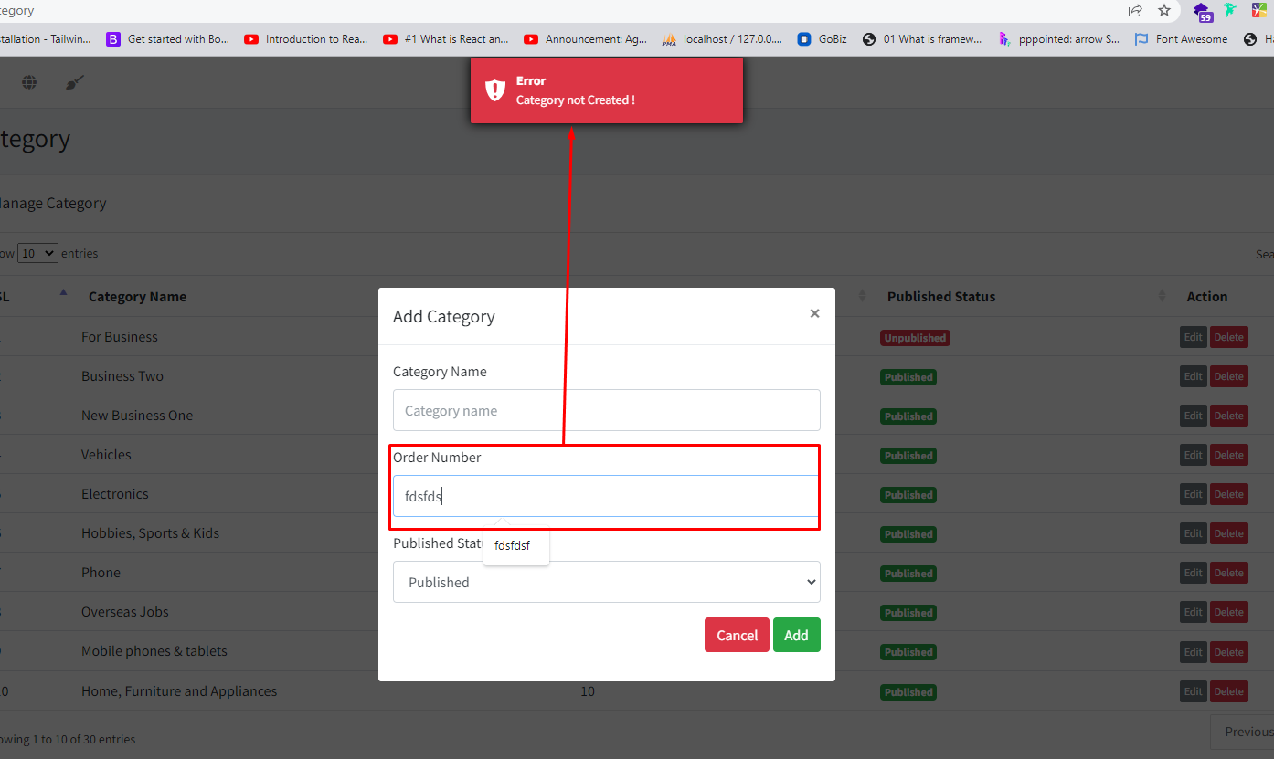

5. Category update message wrong.

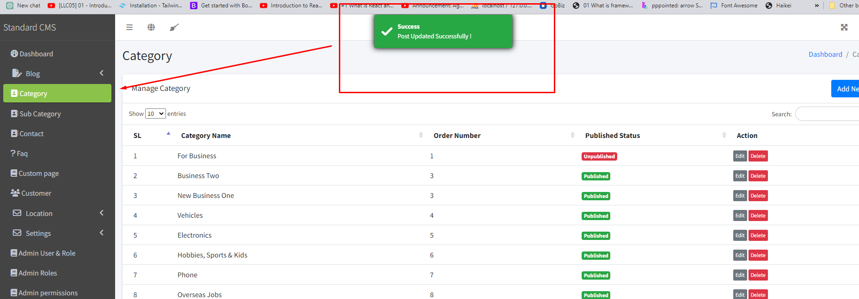

6. Category delete not working.

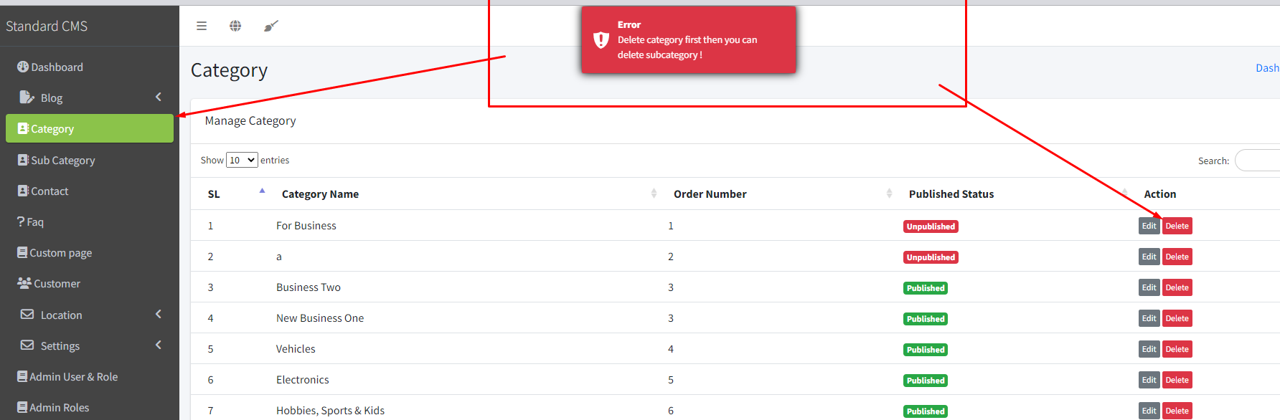7. Change message (Sub Category Added Successfully)

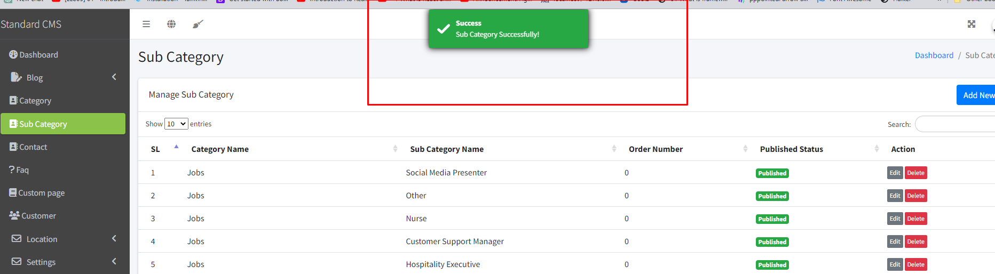

8. Change message (Subcategory Deleted Successfully.)

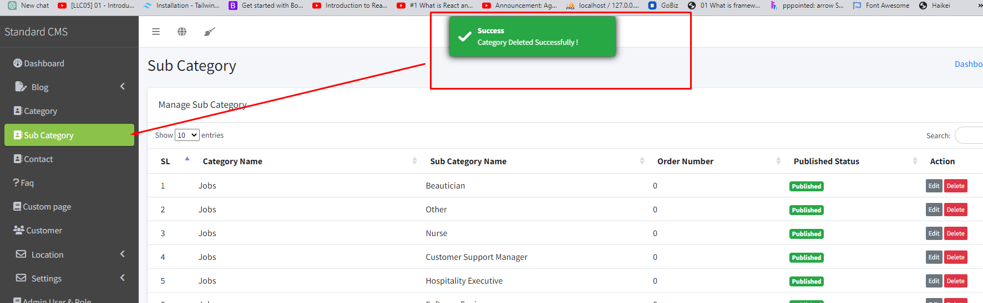9. Change title (Edit Sub Category)

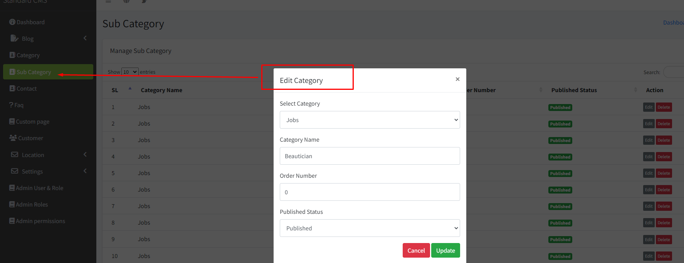

10. Increase Answer field height. Add & edit page

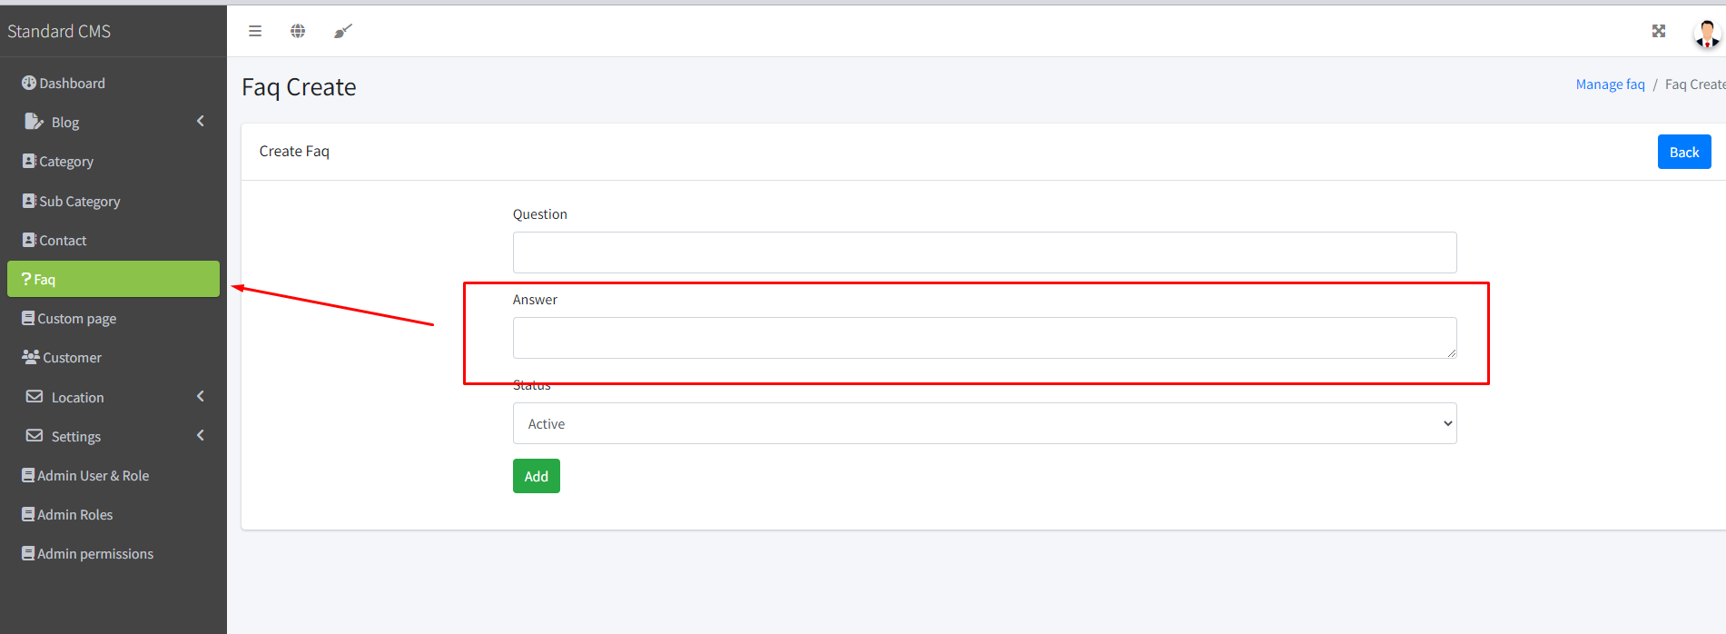

11. Change text Faq edit to Faq View

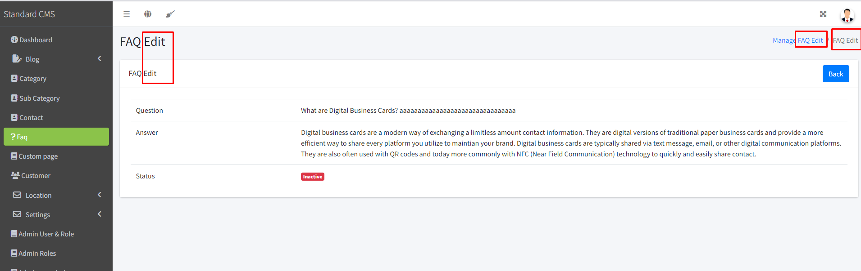

12.Check it

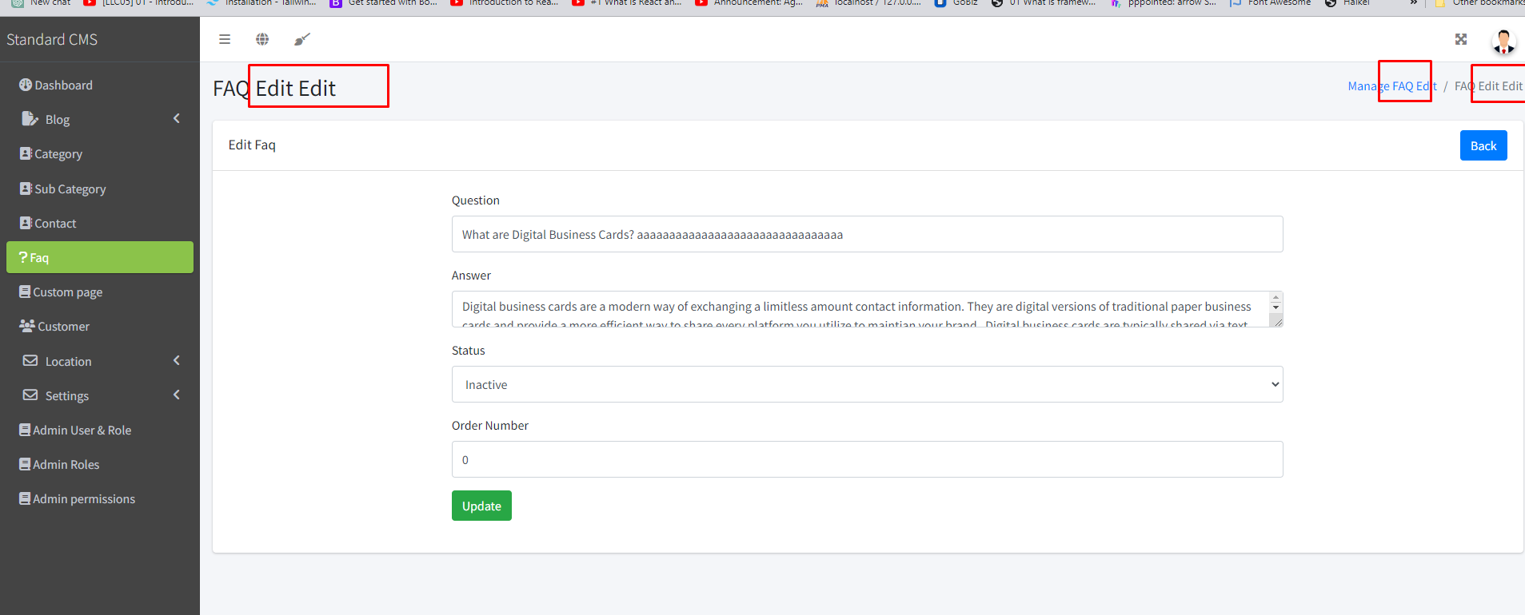

13. Some pages Published Status is (Published) & Some pages Published Status is (Active). Status should be only (Published or Active) Check all pages. 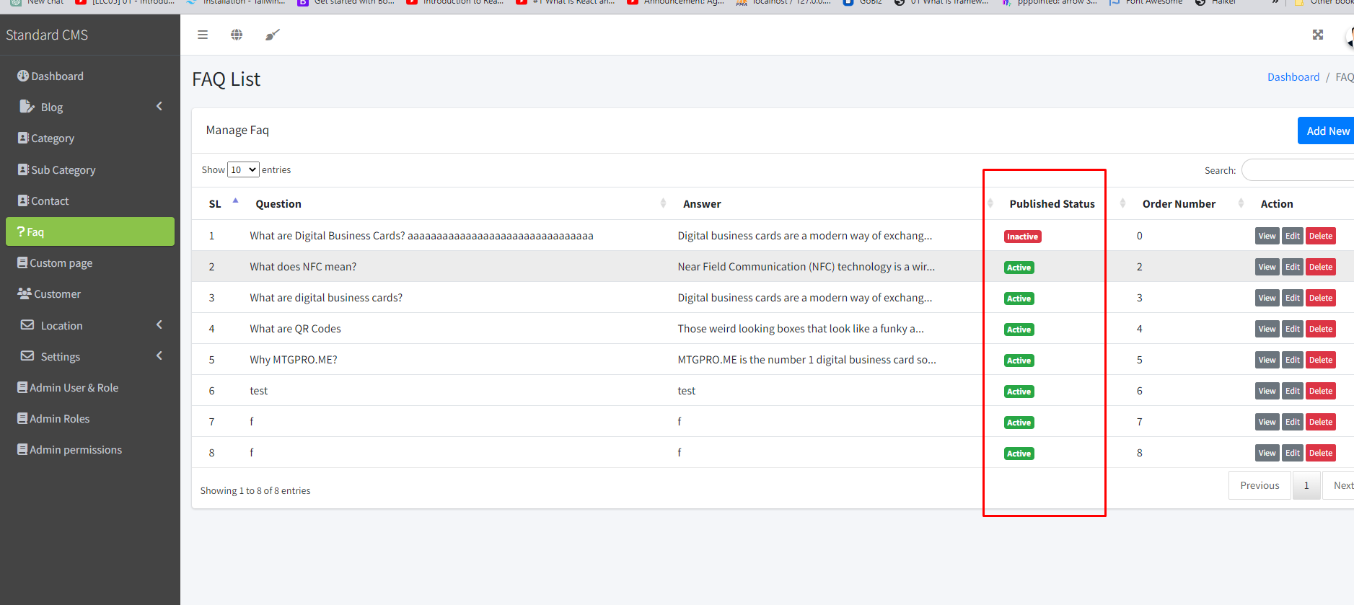

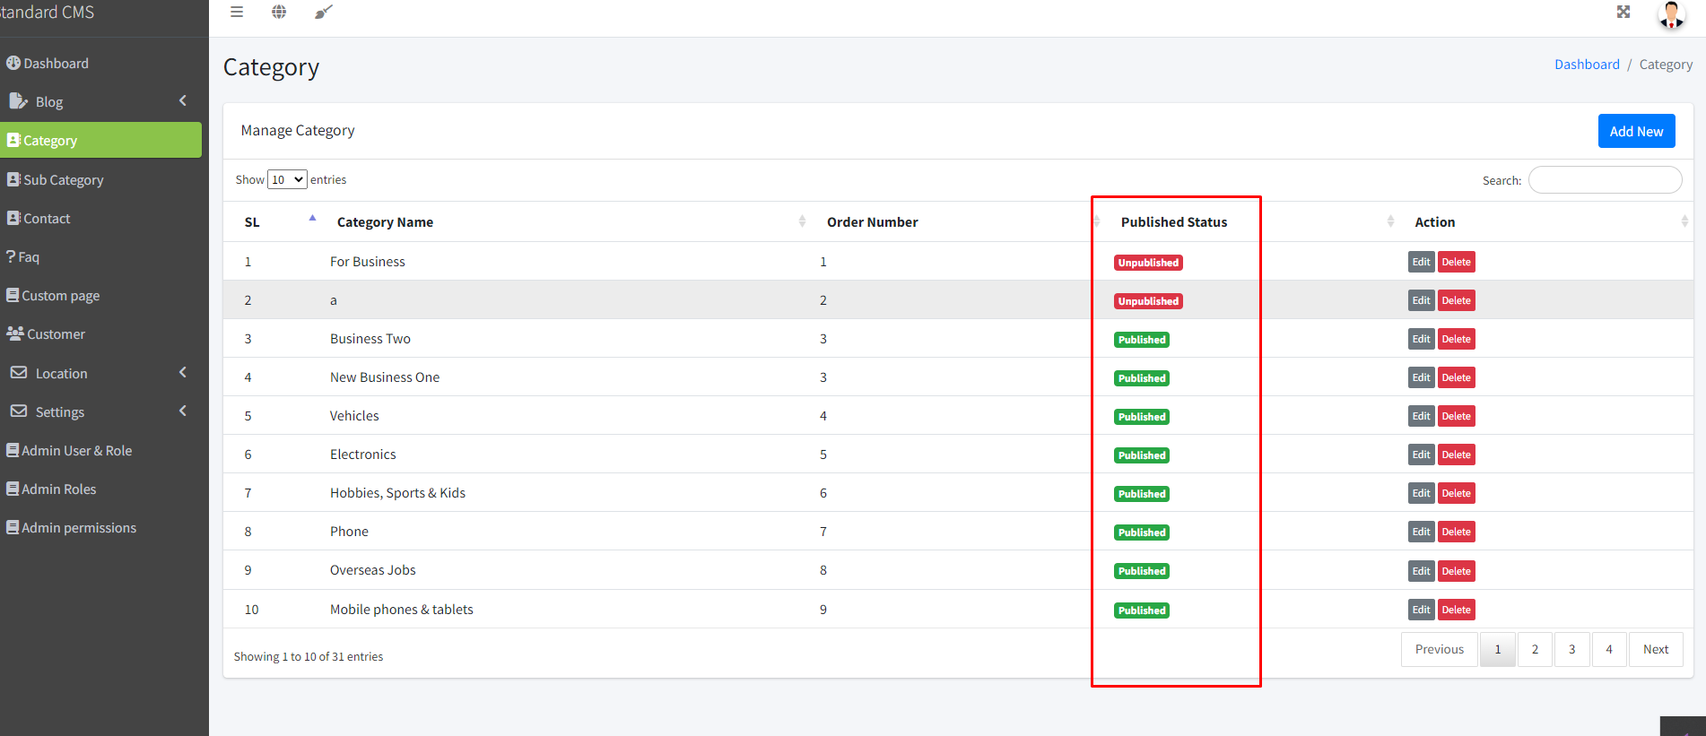

14. Faq Delete

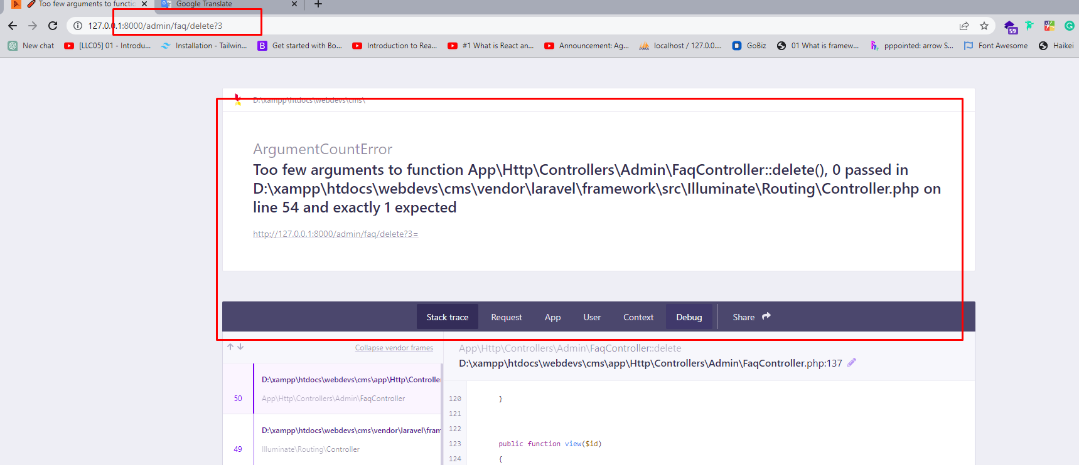

15. The custom page menu is not active

. the description field should be more height. Add & edit page

. The slug should be auto-generated.

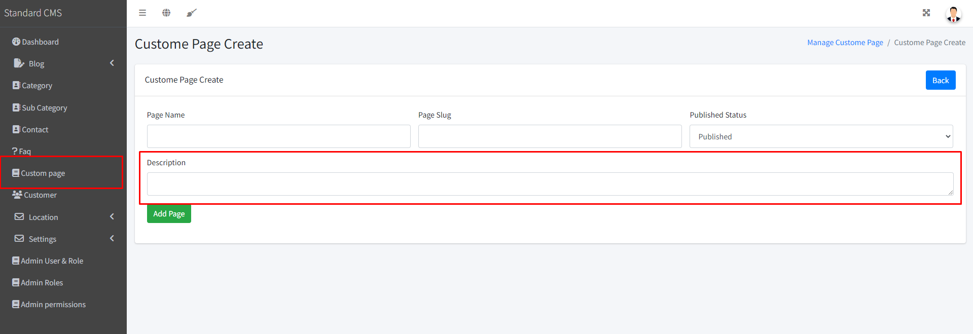

16. Check Properly edit page

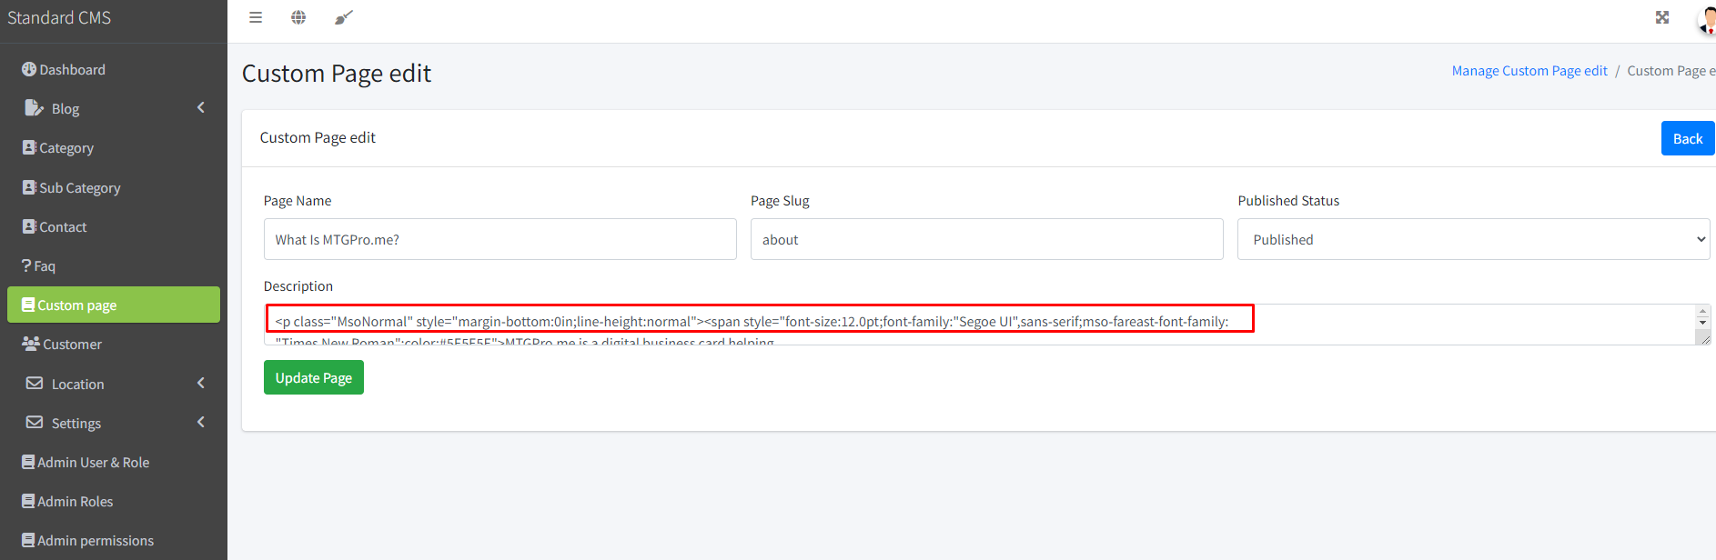

17. Custom page Created not working.

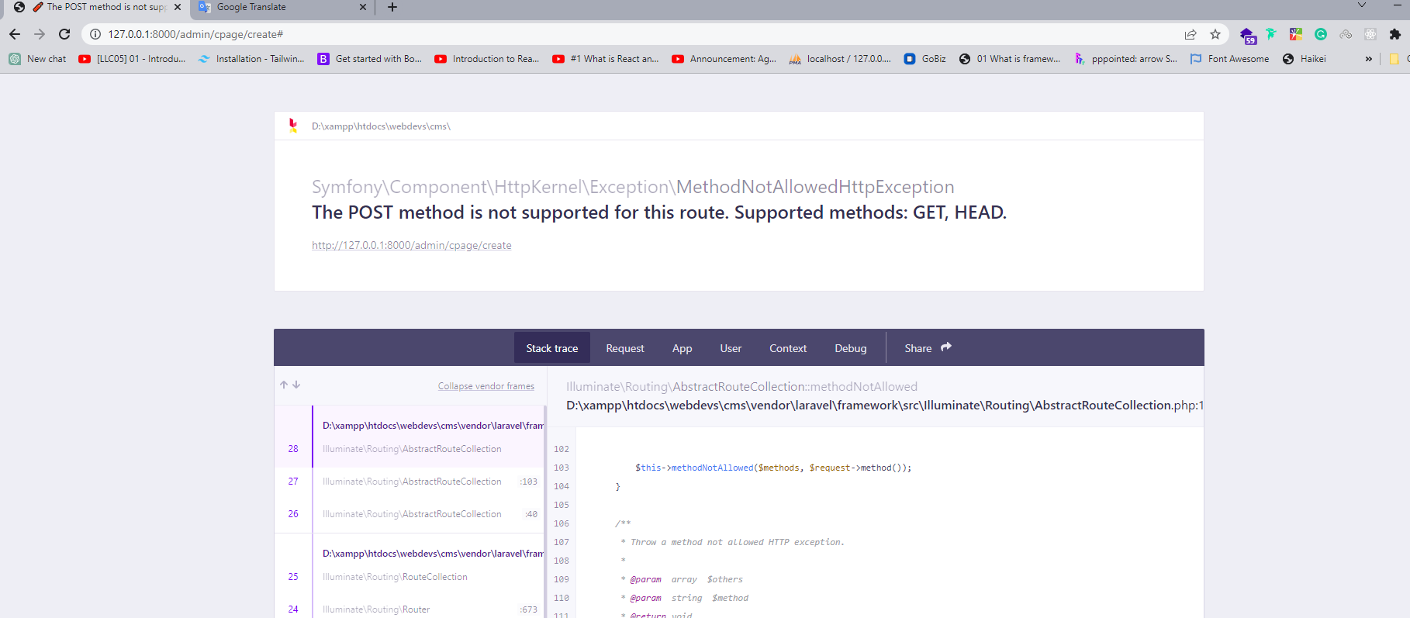

18. Custom page Deleted not working.

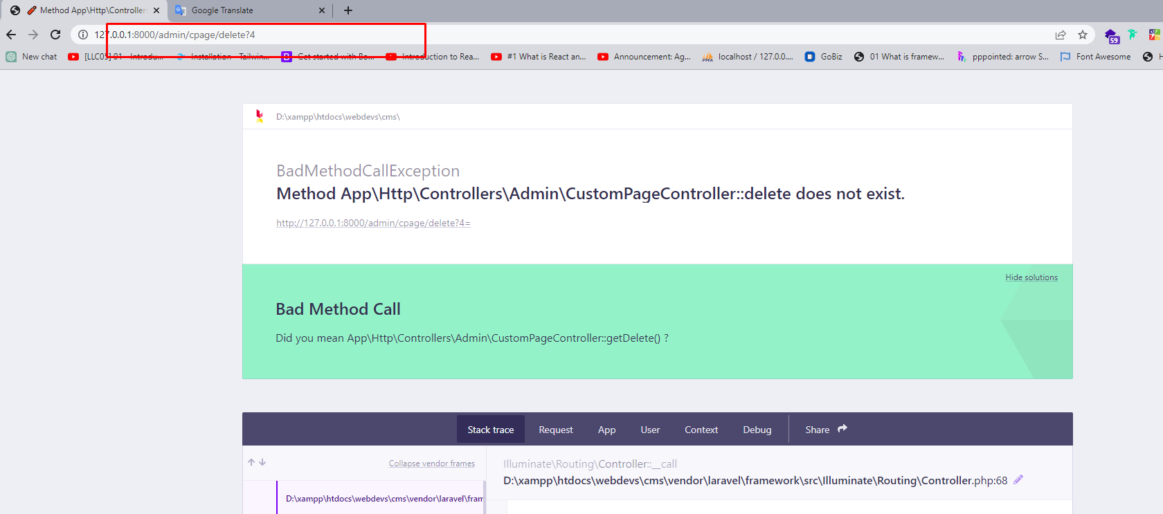

19. Country Added Succesfully

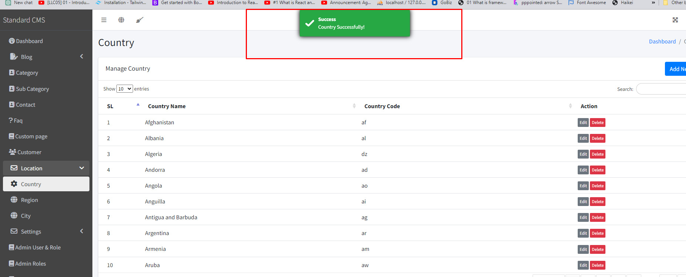

20. Country update not working.

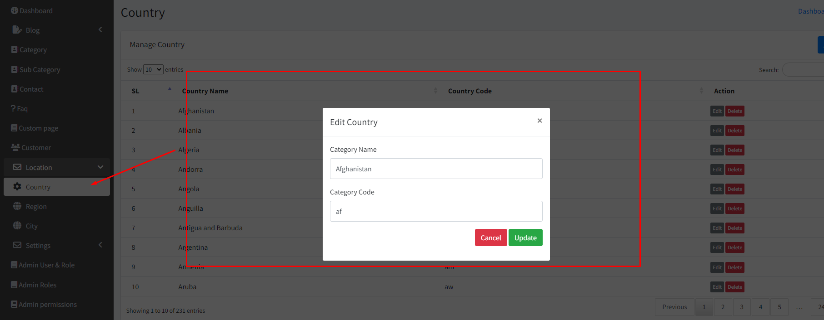

21. Change Placeholder Order Number to Code

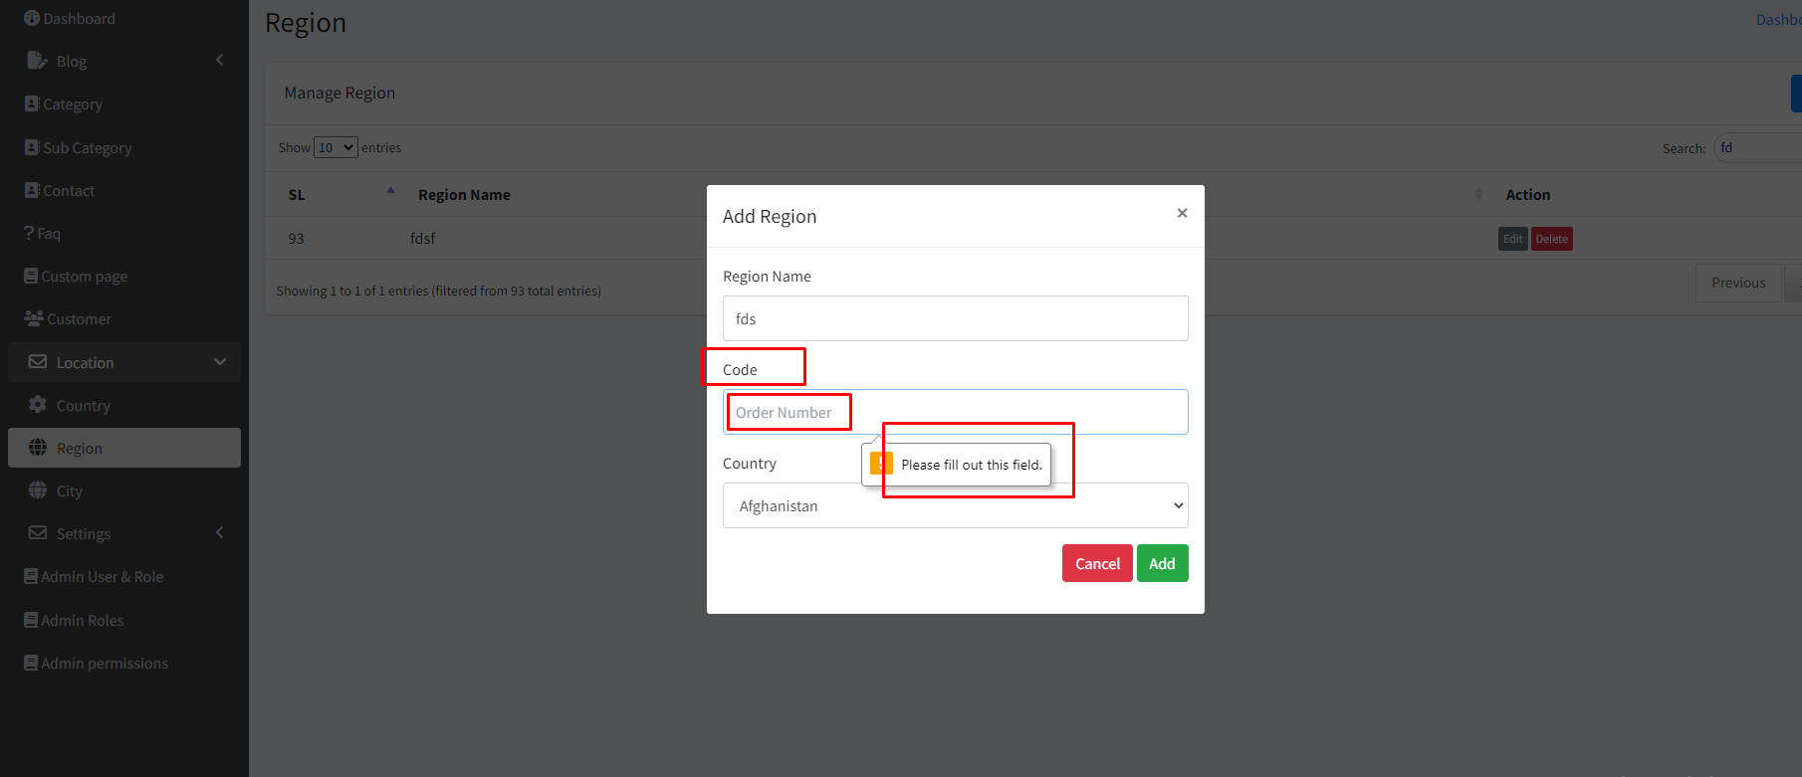

22. Region edit error

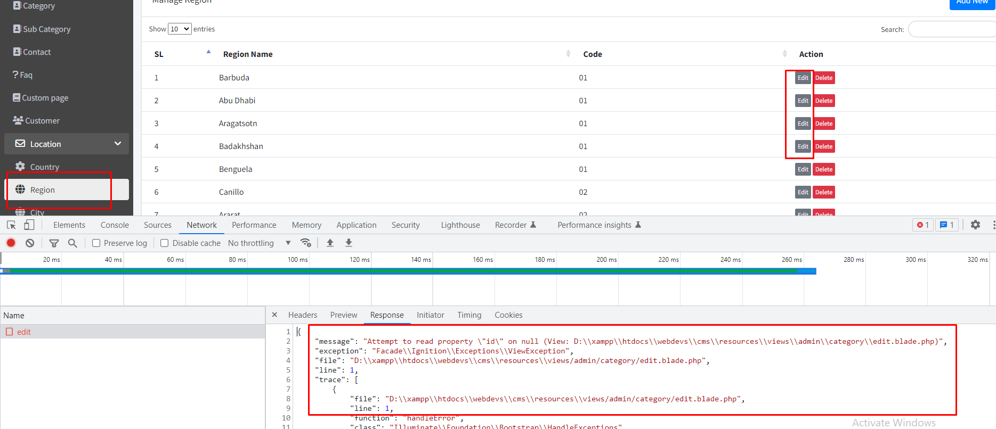

23. This is not a region edit modal check it.

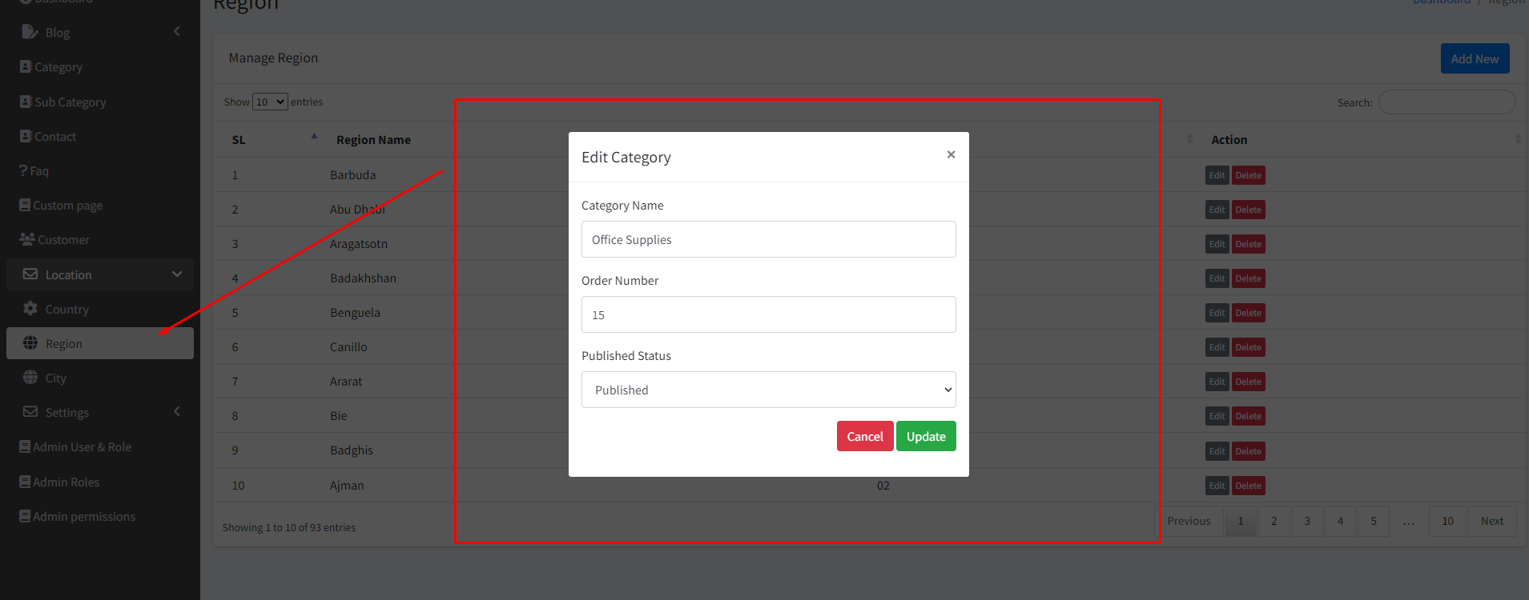

24. This is not city table data.

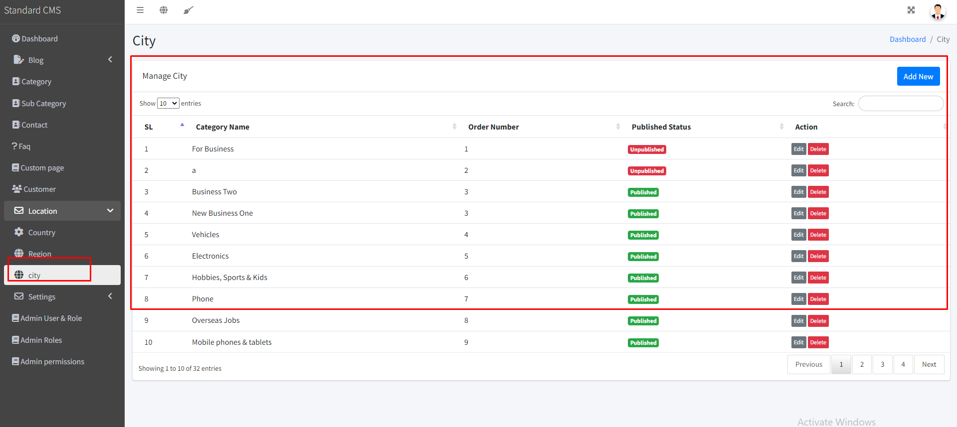

25. Please show this message in Toaster.

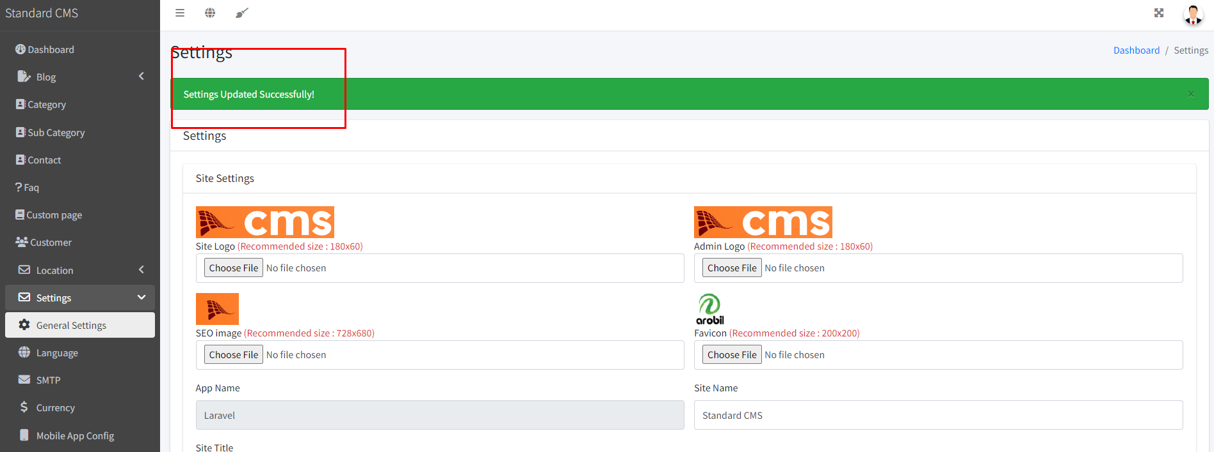

26. Settings -> Language menu not activated.

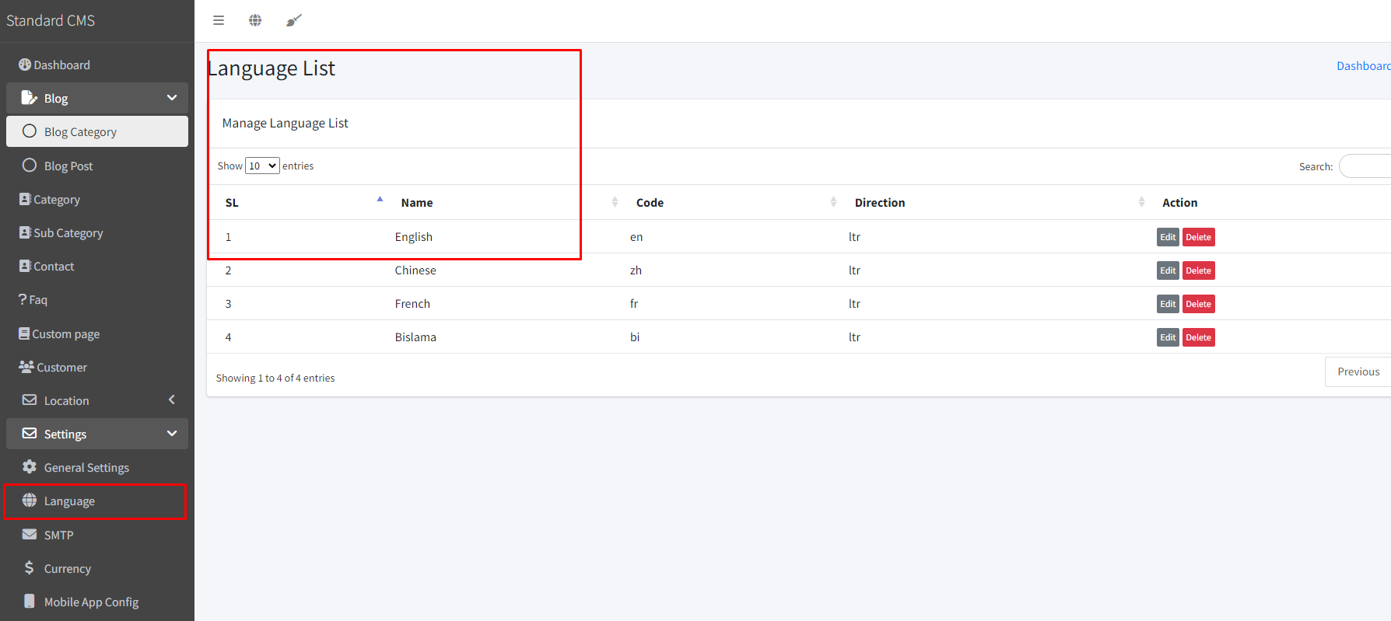

27. This is not language create modal.

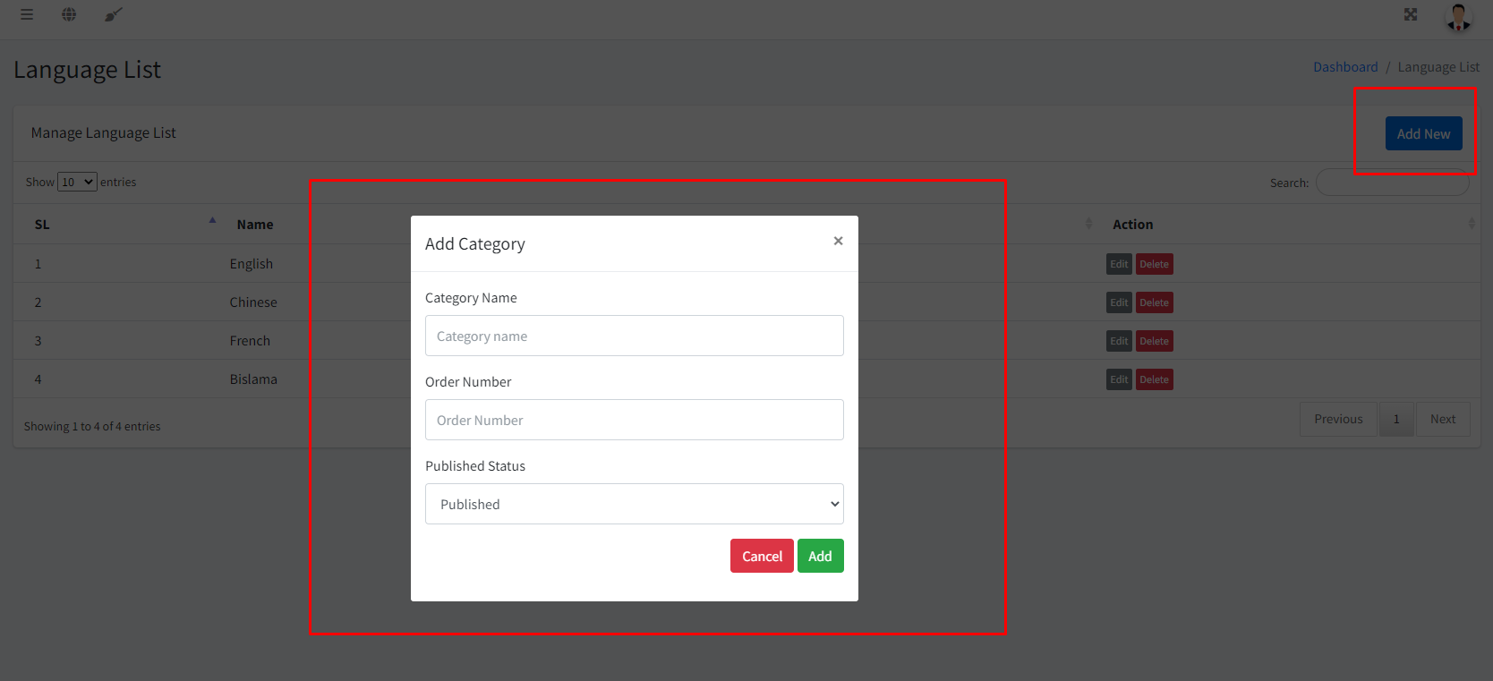

Edit modal not working.

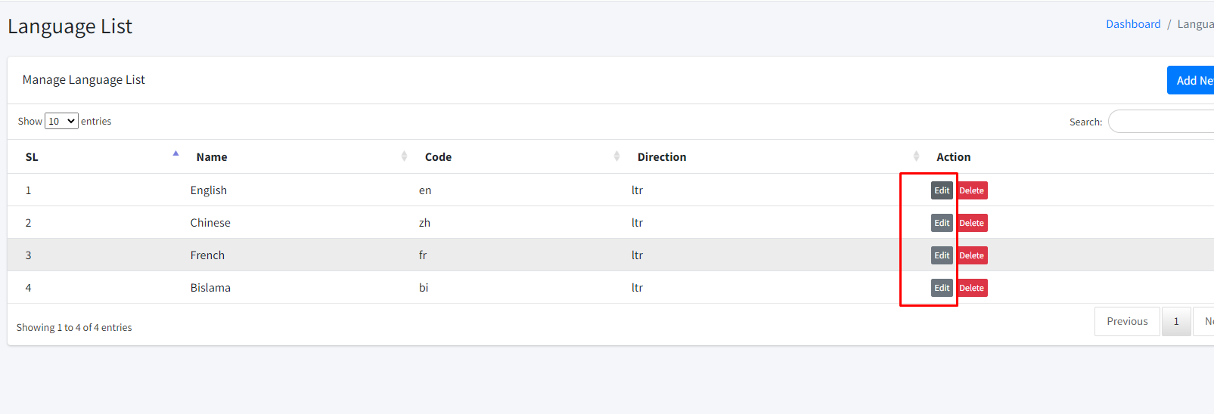

Language Delete not working.

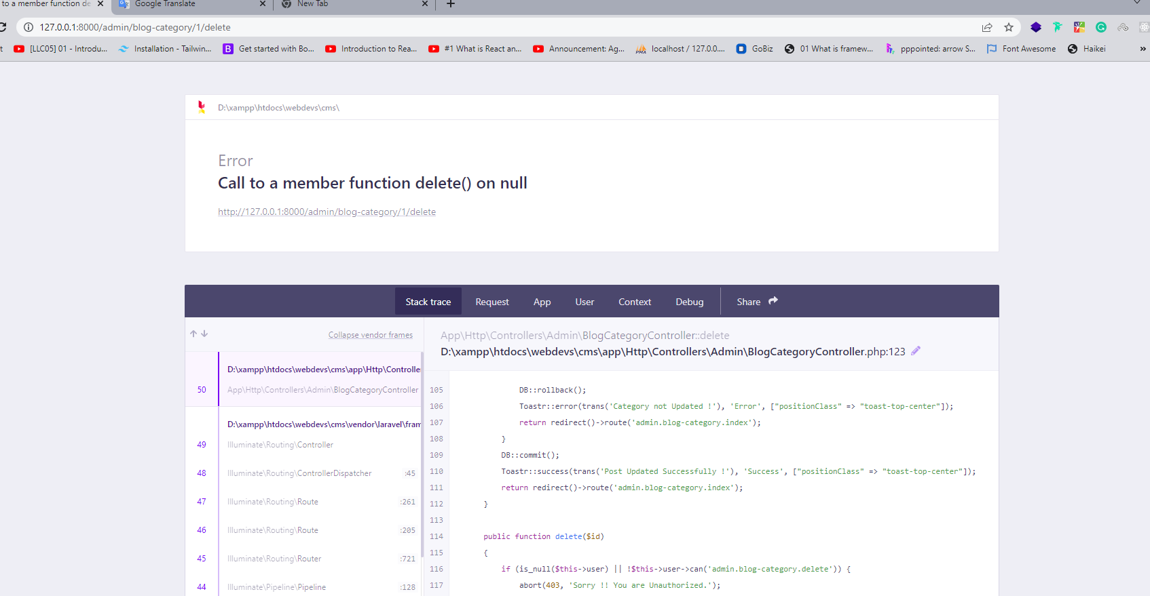

28. SMTP menu not active

.Change Page header -> SMTP

. page design problem

. Update not working.

.Test mail not working.

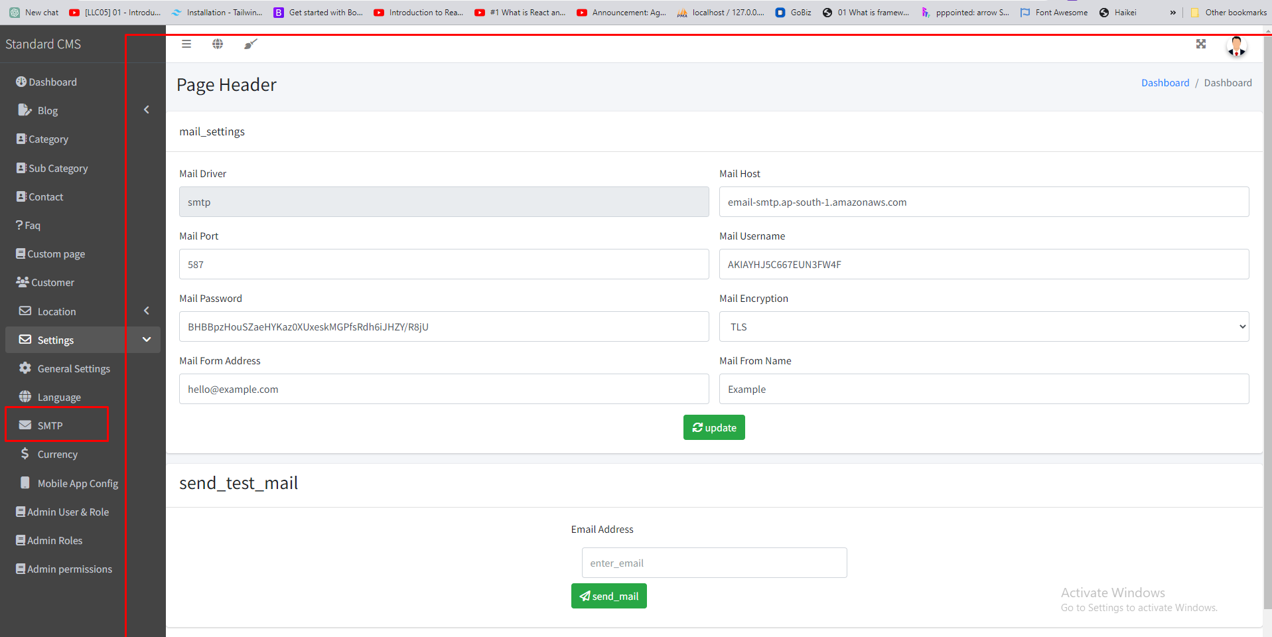

29. Currency menu not active.

.Change page header -> Currency

.Remove save button

.Add button not working

.Check Example button error

.Delete error

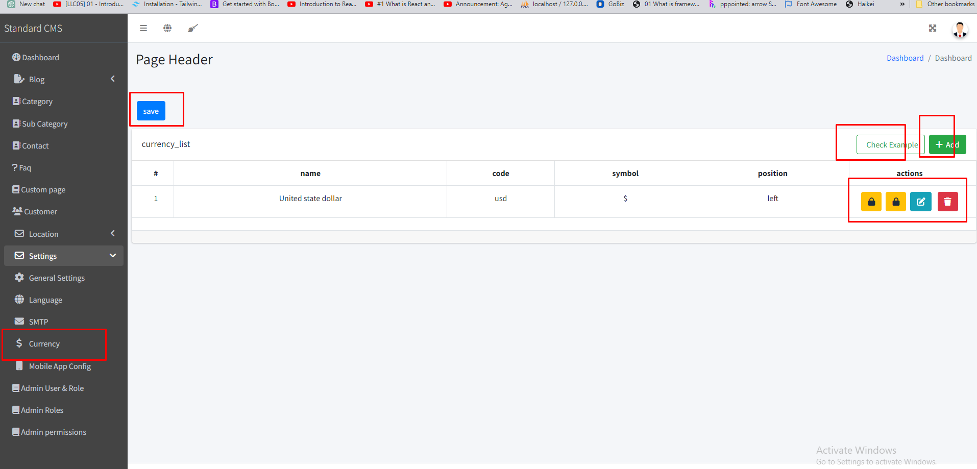

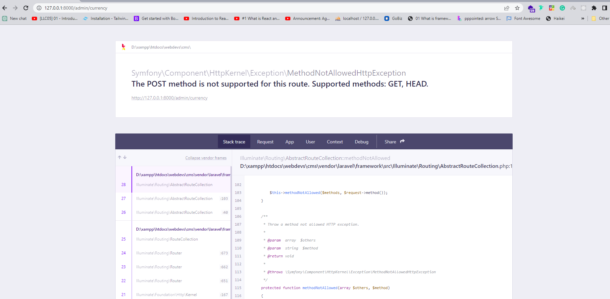30. Change page header -> Mobile App Config

.Update not working.

. The update button text should be outside on i tag.

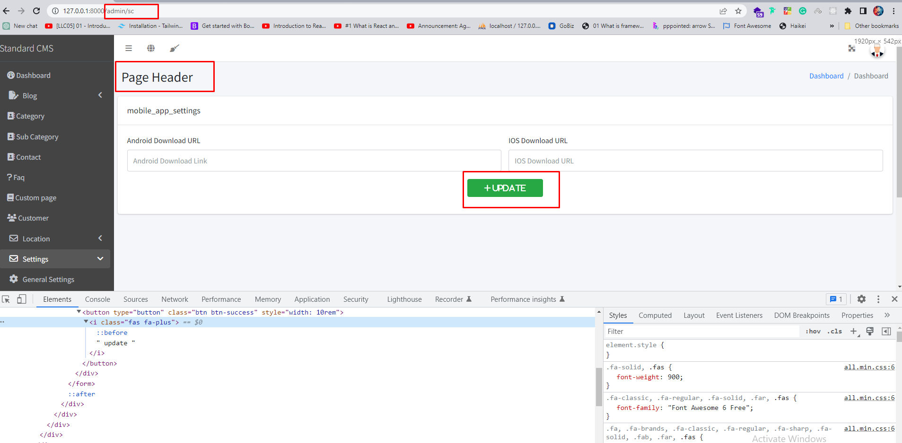

31. Delete not working.

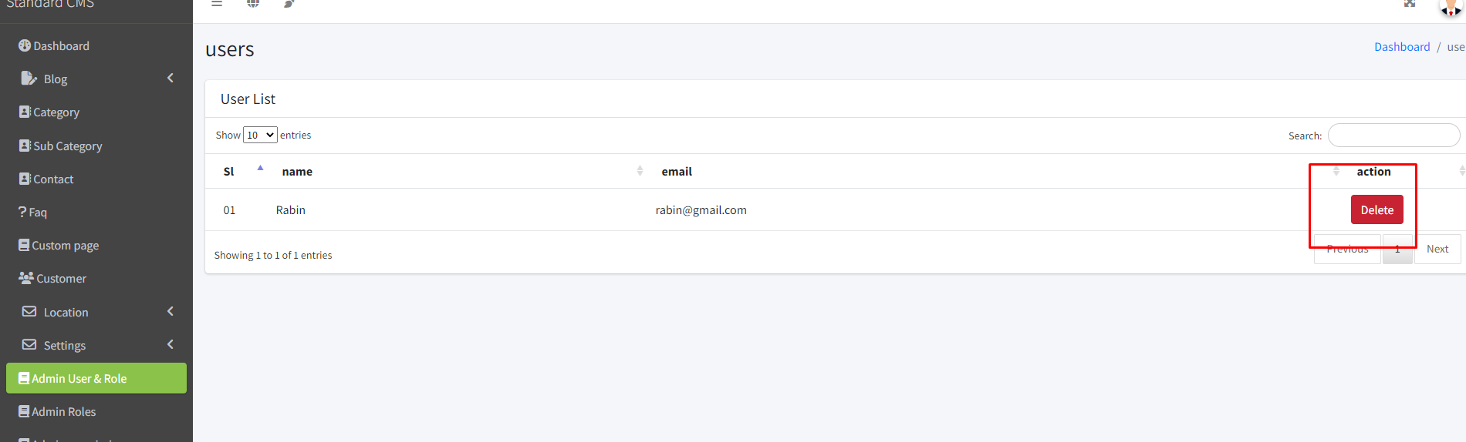

32. Admin role view page.

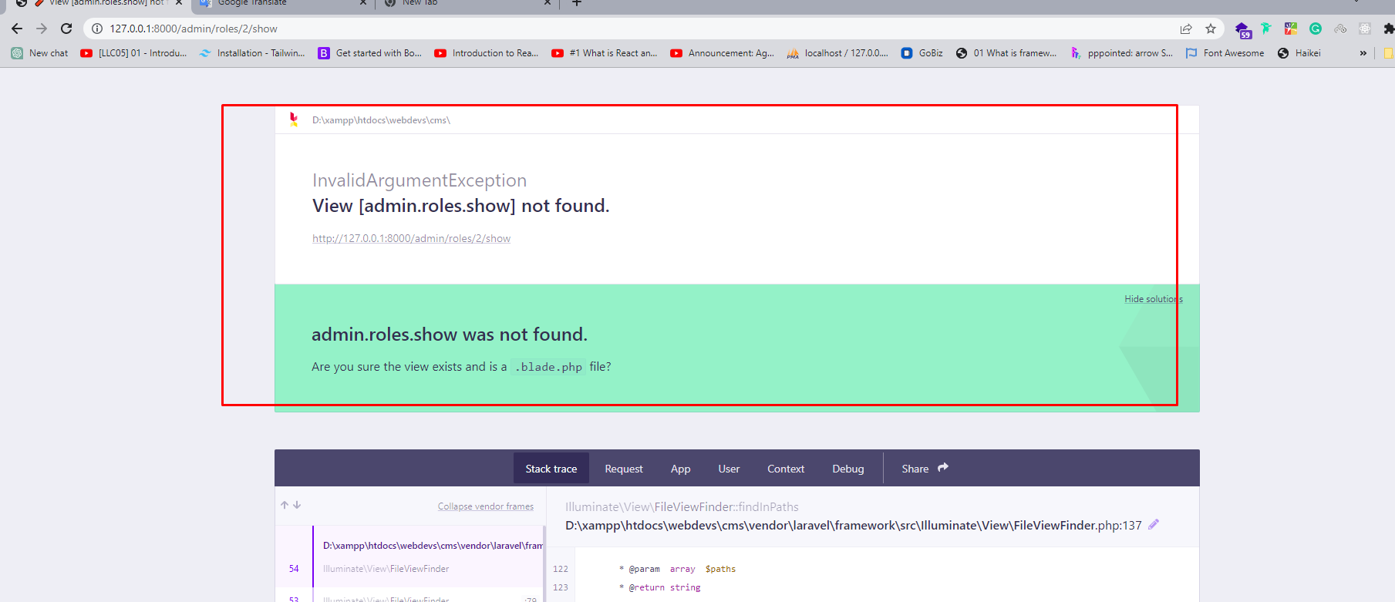

33.Admin roles add, edit & delete page please use toaster message.

34. When scrolling the page sidebar should be fixed.

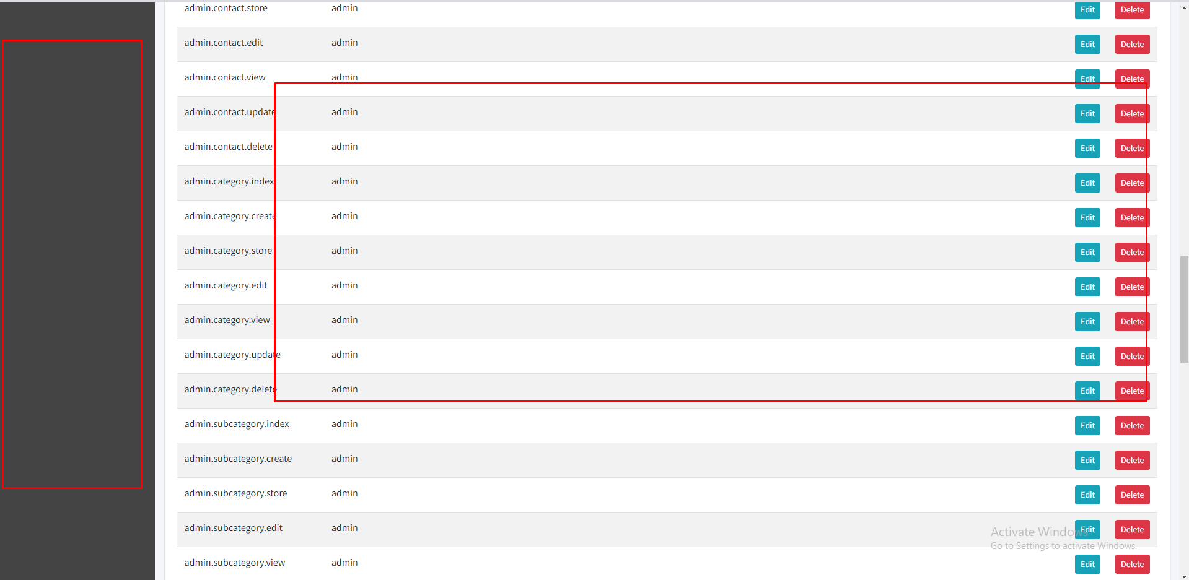

35. Arrow icon

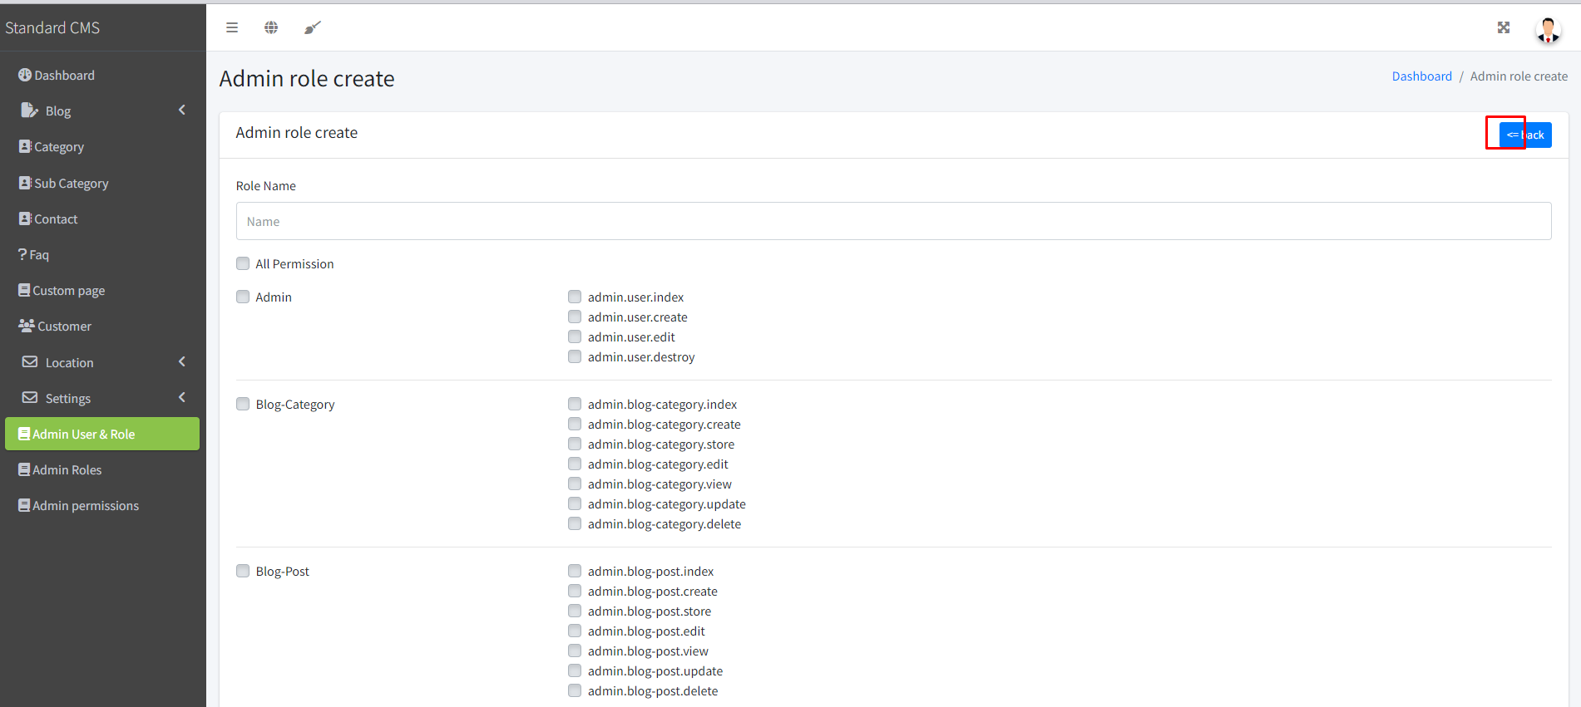

36. Error

